Password Reset via User Profile

Objective
Allow the employee to reset their own password via the Microsoft 365 portal, without requiring IT analyst intervention.
Note: If the user has Citrix and it is a first access, perform via AD only

Responsibility
The employee themselves performs this process. The IT analyst can provide guidance if needed.

Step-by-Step
- Access the site: https://myaccount.microsoft.com/
- Click on your photo in the upper-right corner of the screen and then click "View Account":
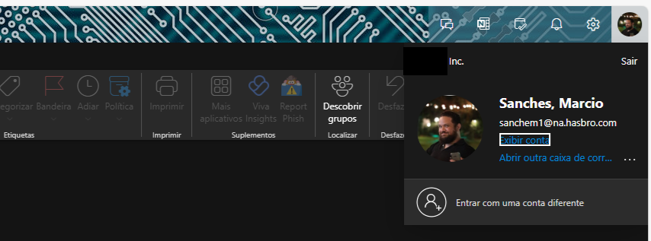
- Click on one of the password change options visible on the screen:
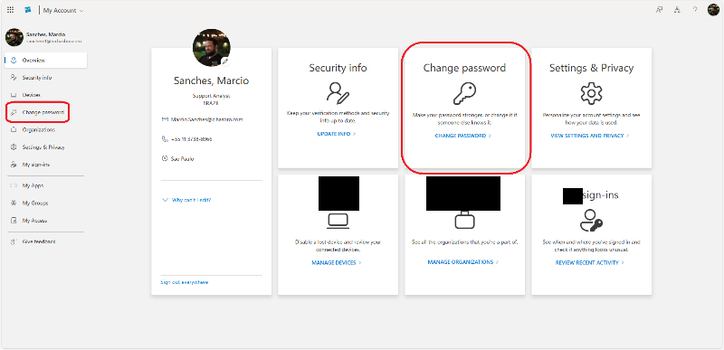
- Set the new password following the standard: uppercase and lowercase letters, numbers, and special characters:
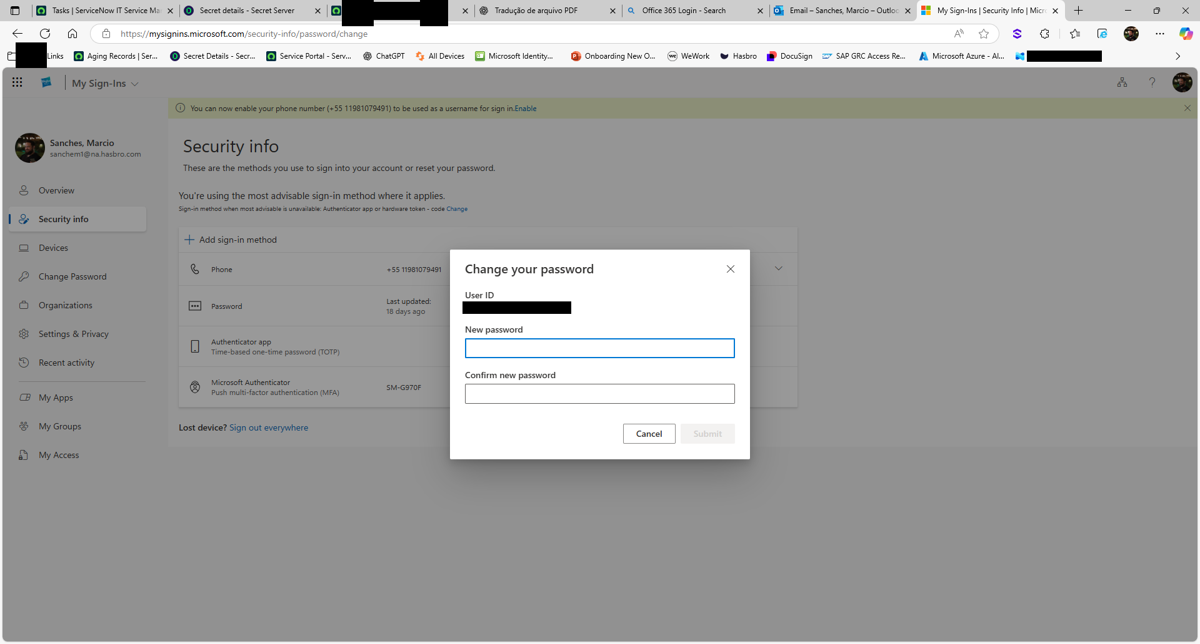

Version History
IT Team | 1.0 | 28/07/2025 | Creation
Lucas Souza | — | Jun/2026 | Process separation
Lucas Souza | — | Jun/2026 | Document standardization

